2019-2020
BOARD OF DIRECTORS’ APPLICATION
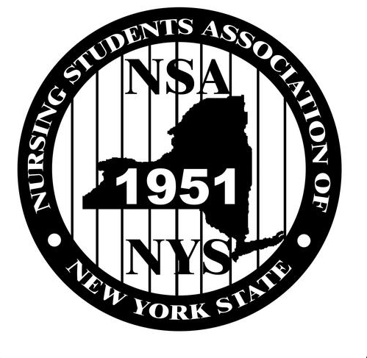

NURSING STUDENTS’ ASSOCIATION
OF
NEW YORK STATE
(NSANYS)

Pre-Slate Deadline:
Wednesday, January 16th, 2019 by 11:59PM

*Please note: all ELECTED 2019-2020 Board of Directors must stay overnight 2/9/19, in preparation for
​ the Transition meeting ​on Sunday morning.

Please submit application and direct all questions to
Mary Andrews, the Nominations & Elections Director,
at nec.nsanys@gmail.com.
SECTION 1: GENERAL INFORMATION

Name: _______________________
NSNA Member #: _______________
Expiration Date: ________________
Email Address: _________________
Mailing Address: _______________
City: ________________________
State: _______________________
Cell Phone #: __________________
School of Nursing: ______________
City (of school): ________________
Anticipated Graduation (Mo/Yr): ____
Type of Program (circle one):
ASN / BSN
Other: ________
Current Nursing Licensure (circle one):
RN / LPN / None
# of credits for current semester: ____
# of credits for next semester: ______
List any leadership positions you’ve held (school/other): ____________________
___________________________________________________________
___________________________________________________________
___________________________________________________________

SECTION 2: BOARD OF DIRECTORS’ POSITIONS
Rate 1-3, 1 being your most preferred position.

EXECUTIVE BOARD:
___President
___Co-Vice President (2)
___Secretary
___Treasurer
___Breakthrough-to-Nursing Director
___Communications Director
___Community Health Director
___Policy & Education Director
___STAT Editor

*AUXILLARY BOARD (Regional Directors)
___Regional Director of
Central, Genesee-Valley, Long
Island, Metropolitan, Mid-
Hudson, Northeast, Western
___I would like to be considered for Regional Director Chair/Nominations & Elections Director

*Region to be determined at Transition Meeting

SECTION 3: GOALS FOR OFFICE
Please list three (3) detailed NSANYS-related goals (that you wish to accomplish as a member of the NSANYS Board).

Please list three (3) personal goals that you would hope to achieve by the end of the term by working with NSANYS.

SECTION 4: NURSING DIRECTOR CONTACT INFORMATION
Complete with information of your Nursing Dean, Director or Chair,
whichever is applicable.

This is my (circle):
Nursing Dean, Director of Nursing, Nursing Chair, Other:________________
First Name: ____________________________________________________
Last Name: ____________________________________________________
Email: _______________________________________________________
Telephone #:___________________________________________________
Address (school office): ____________________________________________
____________________________________________________________

SECTION 5: CONSENT TO SERVE
“If elected, I promise to serve, the Nursing Students’ Association of New York State (NSANYS), to the best of my ability. I have read and understand the Rules of Engagement (which can be accessed at www.nsanys.org), which are responsibilities I will be held accountable for. I am aware of the time and effort to fulfill the responsibilities for the office to which I may serve (approximately five-eight hours/week).
If elected, I am aware that my Nursing Director, from section 4 of this application, will be notified of my responsibilities to the organization. Additionally, my Nursing Director will also be notified if I am no longer a part of the organization during my elected term, for whatever reason that may be.
To the best of my knowledge, all statements on this application are true. I understand that any false statements, incompleteness, or failure to follow directions on this application may result in my disqualification as a candidate and/or potential NSANYS Office Holder.”

Print Name: ___________________________________________________
Signature of Candidate: ______________________________ Date: _________
SECTION 6: NURSING FACULTY ENDORSEMENT
This section is to be completed by a nursing faculty or administrator that can attest to your character, dedication, and performance.

It is the considered opinion of this faculty member that this student’s record of performance is satisfactory and that the applicant will be able to devote the necessary time and effort to the NSANYS responsibilities.

Academic Unsatisfactory Satisfactory Excellent
Clinical: Unsatisfactory Satisfactory Excellent
Co-Curricular: Unsatisfactory Satisfactory Excellent

If elected, can this student expect support from the nursing faculty/administrative member for participating in official NSANYS activities that are required for fulfillment of responsibilities? Yes No (please explain on separate page of why not)

Name: _____________________________ Title: ______________________
Telephone #:_________________________ Email: _____________________

Signature: ___________________________Date: ______________________

SECTION 7: REQUIRED DOCUMENTS
- Completed Application
- Resume and/or CV
- NSNA Membership Card
- Most Recent Transcript for Proof of Enrollment in Nursing Program
  - You may black out your grades.

