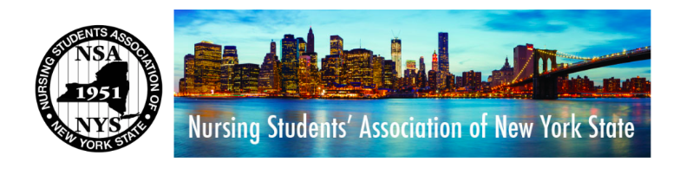
Nursing Students’ Association of New York State 2017-2018
October Board of Directors Meeting
Date: October 16 2017 at 7:00 PM
Location: Google Hangouts Conference Call
- Call to Order
  - The monthly meeting of the Executive Board of Directors of the Nursing Students’ Association of New York State was called to order at 7:05PM by Annie Nelson, President.
- The Roll: The roll was called by Kezia Varughese, secretary.
Present:
  - President - Annie Nelson
  - Co-Vice President: Paige Denney
  - Co-Vice President - Erica Debobes
  - Secretary - Kezia Varughese
  - Treasurer - Alexa Vines
  - STAT Editor - Katy Chen
  - Nominations and Elections Chair – Lindsay Roblyer
  - Community Health Director - Helen Pham
  - Professional Advisor - Larry Slater
ABSENT
  - Breakthrough to Nursing - Patrick Wlodkowski
  - Policy and Education - Elizabeth Gambo
  - Communications Director - Juliet Kim
  - Giselle Melendez, Presidential Advisor

- President Annie Nelson declared a quorum present (9 members).
- President Report: Anne Nelson
  - Highlights of the report include the following:
- COSL Review
- Discussed COSL with executive board members (strength, weaknesses, overall)
- STRENGTH
  - Quality over quantity
    - Those who attended gave positive feed back
    - More chapters created after attending COSL
    - Increase in NSANYS/NSNA interest
    - Many expressed a larger interest in nursing community
- WEAKNESS
- Invoice is approximately 3700 – has not been sent to Larry yet
  - Covers meeting room, hotel rooms, and registration for attendees
- Larry suggested RSVP for COSL should be more strict
  - Attendance doubled than amount who RSVP but didn’t reach the number of attendees from last year
  - Need to send firmer emails
  - Also suggested relationship with ANA New York needs to become better – they felt separated from us
    - Next time be more involved with ANA NY
- OVERALL
  - Great experience and those who attended received resources and information they didn’t know prior

- Treasurer Report: Alexa Vines
  - Account Balances
    - Checking account - $70712,12
    - Savings account – 47359.63
    - Total – 118.071.75
  - COSL REIMBURSEMENT – Juliet Kim
- Spent $38.53
- Alexa Vines motion to approve Juliet Kim’s reimbursement
- All in favor – no discussion
- Action: carried
COSL REIMBURSEMENT – Katy Chen
- Reimbursement of 27.50
- Katy Chen must abstain from voting } conflict of interest
- All in favor – no discussion
- Action: carried
- Finance committee does not require second vote
- Convention Committee Report
- Confirmed and finalized rooms
- Booked transition room for Sunday
- Interview room is booked all day
- 235 registered last year gave agency 250
- Booked room for the board, Giselle and Larry
  - Need 5 for our board and consultants
- Key note speaker uses NSNA board members – we must pay for them and their room
- Need to find a way to create more space to invite more exhibitors
- Finance Committee Report
- Must get together with committee to review budget
- Community Health Report
- Main goal is to set up community health event at convention – similar to ANA COSL
- Collected about 230 items at Equinox GreatFinds
  - Jackets, suits, heels, sneakers, tops, bottoms, handbags,
- Suggested idea of next event with Ronald McDonald house
- Encouraged each board member to attend/host at least one event each year
- STAT Editor
- Goal is for issue to be out by November
- Life after graduation
- Community events
- Goal is for issue to be out by November
- Nominations and Elections Chair
- Chose regional directors
  - Needs to email them
- Awards and scholarships
  - Updated the Jennifer Whalen scholarship and state applications
    - Needs to be updated on website
- Discussed ideas for different awards
  - Ex: Helping Houston Award
- Unfinished business:
- Need to find regional director email accounts and passwords
  - May create new ones
- Bylaws state regional directors are on board of directors but not executive committee
13. New business:
- Meeting times
  - Secretary will send out doodle poll for Sunday mornings
    - 8AM – 11AM
- Midyear conference
  - Which NSANY members are attending
  - November 2nd – 5th
  - Book flight for November 1st – 5th by October 20th until 9PM.
  - Need to Uber/taxi 15 minutes from airport to hotel
- Convention activity
  - Each committee member must create an activity to help members get to know you as a board member
    - Ex: Secretary can host a workshop on taking minutes
14. Association Policies
- Rules of engagement
- Reimbursements
- Each board member must attend a community health event or host one in their region } board participation policy
15. ADJOURNMENT
- The meeting was adjourned by Annie Nelson at 8:07PM.

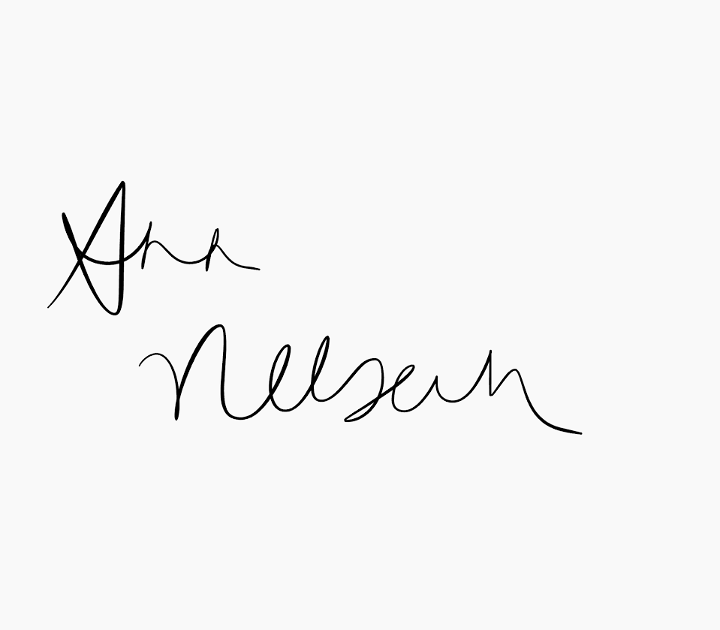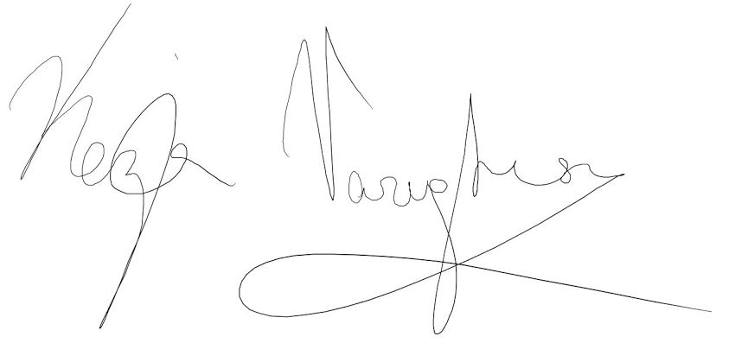
_____________________________ __________________________
Annie Nelson, President Kezia Varughese, Secretary

